Hackathon-3 Project Proposal
Theme: Data Engineer
Title: Predicting Student Academic Performance Using Term Grade Data

Abstract
This project proposes a machine learning system that predicts student academic performance in upcoming subjects using historical grade data from previous academic terms. Academic records are stored in a structured SQL database and processed through a reproducible training pipeline. Traditional machine learning models are trained to forecast expected grades, with evaluation metrics validating performance. A Streamlit dashboard enables visualization of academic trends and real-time prediction input. As new term data becomes available, the system supports retraining and model updates, simulating a lifecycle deployment environment. The goal is to create a production-ready academic analytics pipeline that supports data-driven academic planning and performance monitoring within a university setting.
Problem Statement
Universities accumulate multi-term academic performance data but rarely utilize it for predictive academic guidance. Students often lack early indicators of performance trends when enrolling in new subjects. This project addresses the need for a predictive academic system that analyses historical grades to estimate future performance. By converting academic history into a structured machine learning pipeline, the system enables proactive decision-making, performance monitoring, and continuous improvement through periodic retraining.

Proposed Solution
The system collects anonymized academic records spanning past terms, each containing grades for multiple subjects. These records are stored in a structured SQL database. Traditional machine learning models such as Logistic Regression, Decision Trees, and Random Forests are trained to predict a student’s expected grade in a new subject. A dashboard built using Python frameworks enables visualization of grade trends and provides an interactive interface for predictions. When a term concludes, the new grades are appended to the dataset and the model is retrained, ensuring lifecycle continuity and improved predictive capability.

Expected Output
- A trained predictive model estimating subject performance
- Dashboard showing multi-term academic analytics
- Interactive prediction interface
- SQL-backed academic dataset
- Automated retraining workflow
- Version-controlled ML pipeline

Model Training & Implementation
The system will use historical academic grade data from four previous terms, stored in a structured SQL database. A Python-based training pipeline will retrieve this data, prepare it into structured features, and train a Random Forest model to predict a student’s grade in a selected upcoming subject.
The mid-term implementation will demonstrate:
- Successful connection to the SQL database
- Model training using stored academic data
- Evaluation metrics including accuracy, confusion matrix, precision, and recall will be used to validate model performance.
- Generation of prediction results for sample inputs
These outputs confirm that the predictive pipeline is functional and connected to persistent storage. The trained model will be saved and reused for dashboard-based predictions.

Dashboard
A Streamlit dashboard will act as the interface between the stored academic data and the prediction system. During the mid-term demonstration, the dashboard will display:
- Summary visualization of multi-term grade data
- Model performance metrics
- A prediction input section where users can enter academic history and receive predicted grades
This dashboard establishes an interactive environment that connects the SQL database, trained model, and user predictions in real time. The dashboard includes dynamic visualizations and a live prediction interface to ensure interactive usability.

Deployment Section
The model will be retrained at the end of each academic term when new grades are available. This periodic update cycle ensures model relevance and system reliability. Newly completed academic terms will be appended to the SQL database, triggering retraining of the predictive model. Updated model versions will replace previous ones while maintaining version history. The dashboard will automatically use the most recent model, ensuring predictions remain aligned with evolving academic data.
Project Timeline
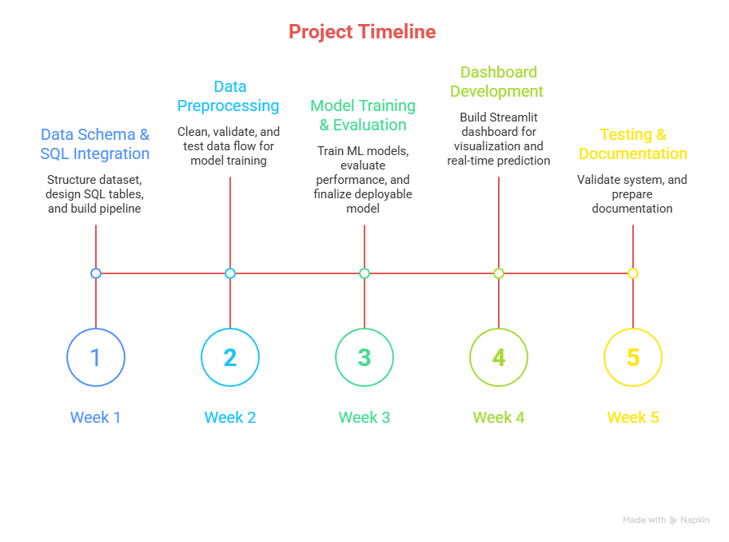

Parth Sachin Bhirwandekar
2024SEPVUGP0022

